**Ping google**

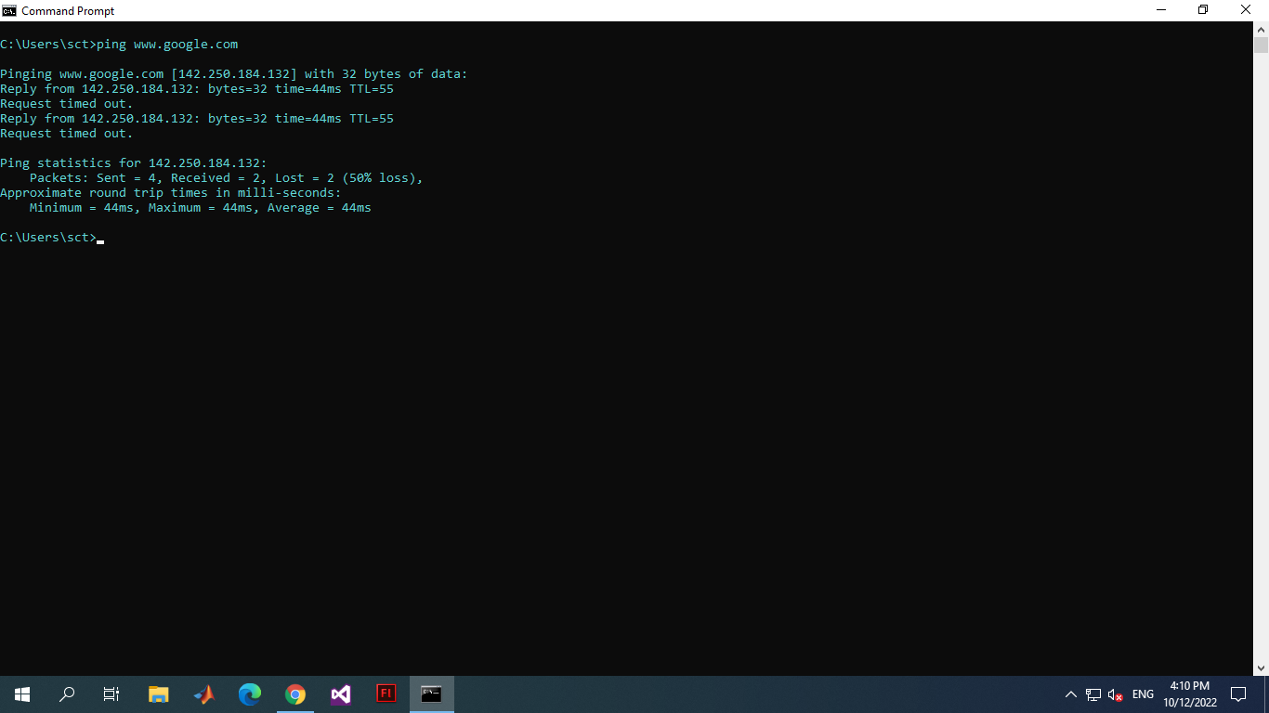

**Ipconfig & ipconfig /all**

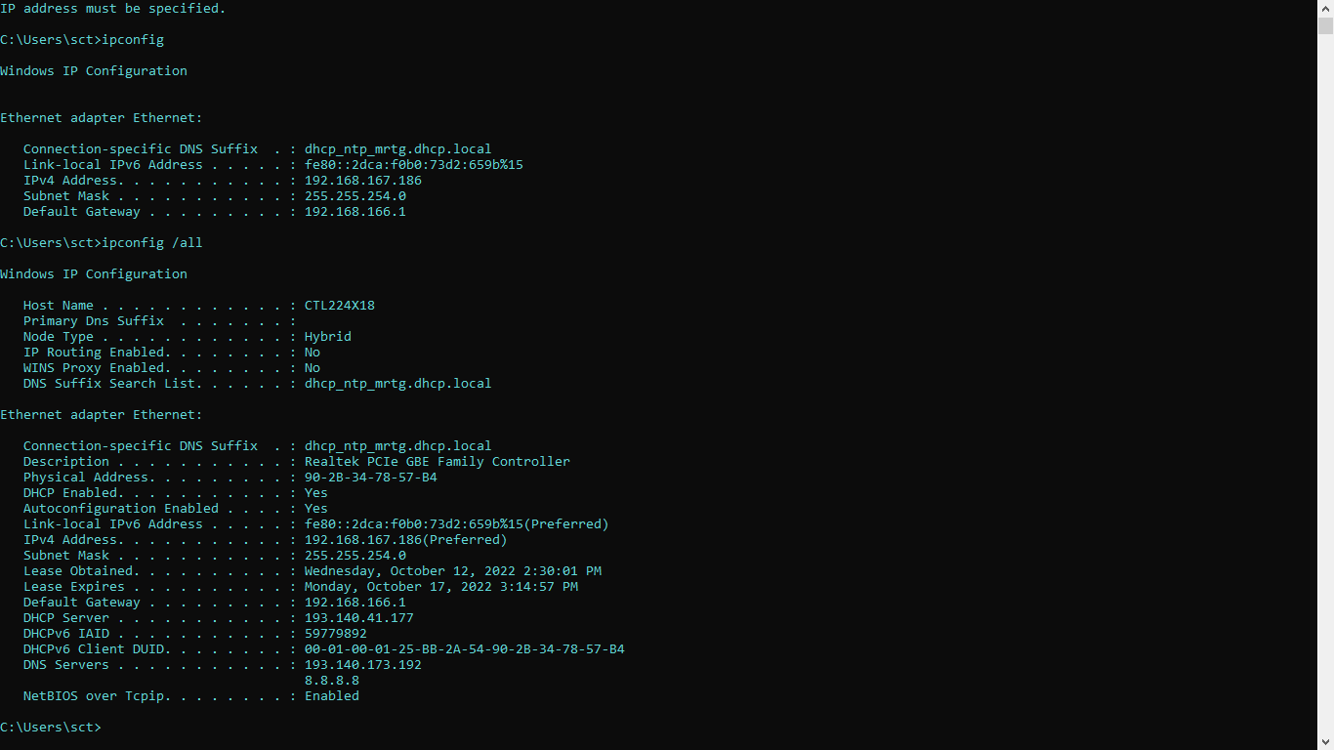

**Ipconfig -?**

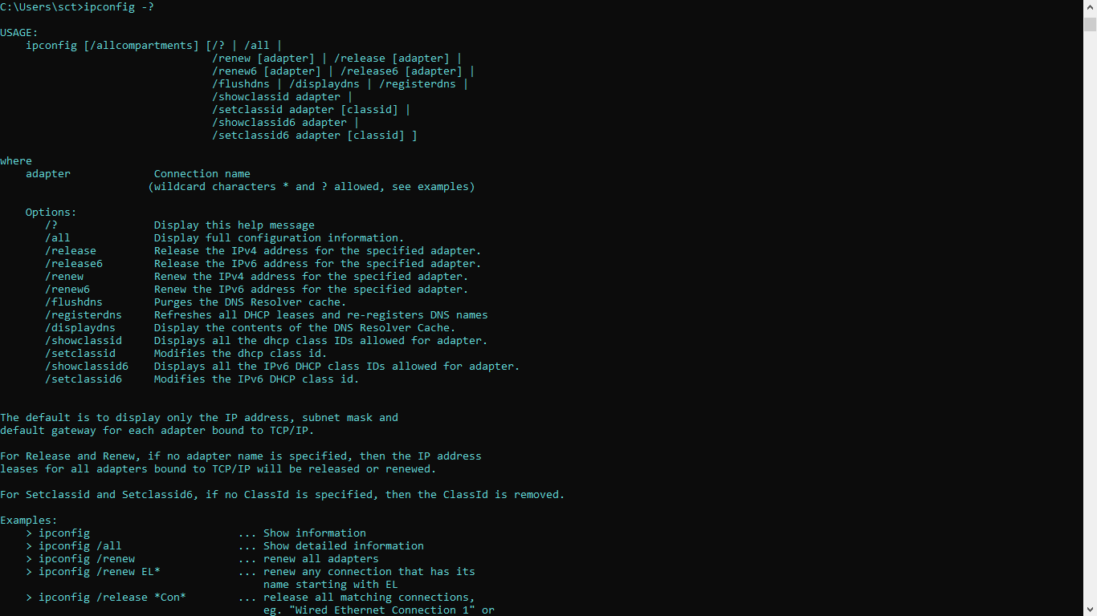

**Tracert** [**www.google.com**](http://www.google.com)

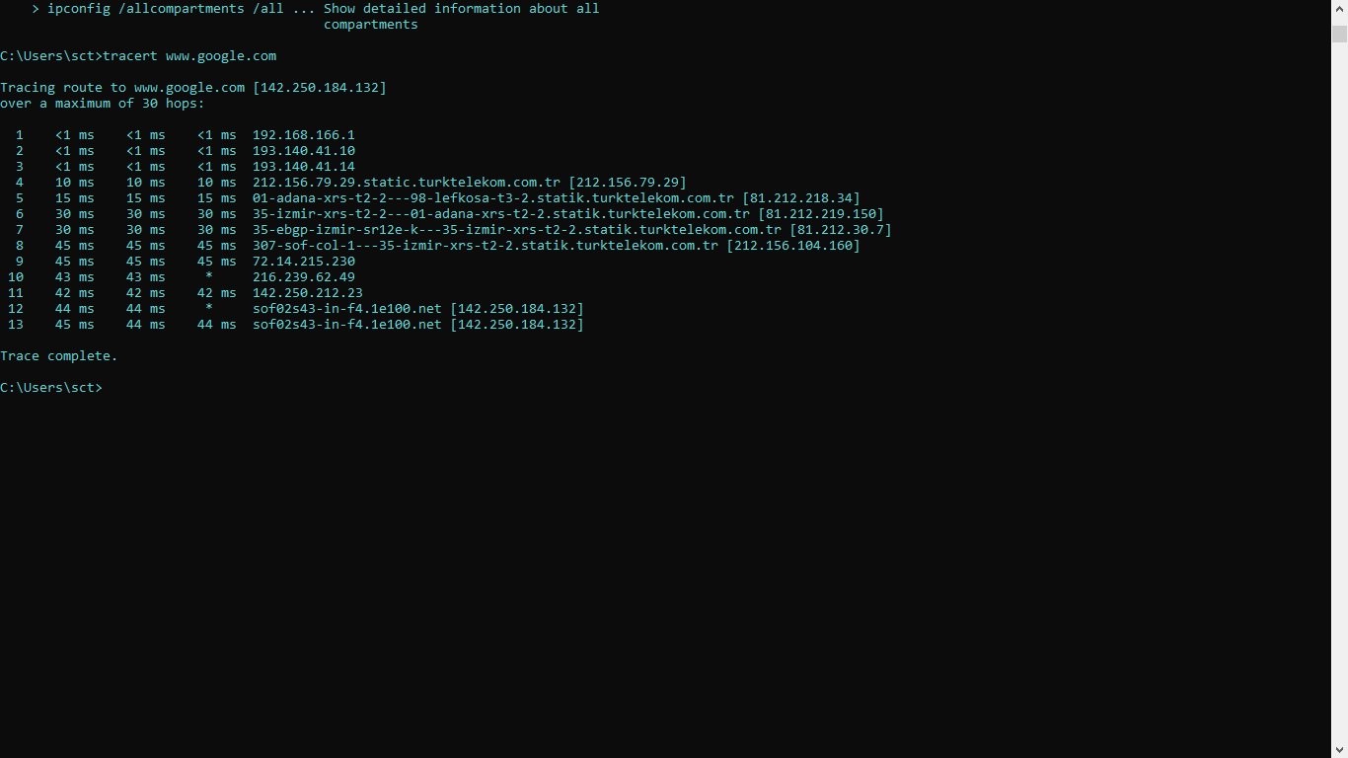

**Netstat**

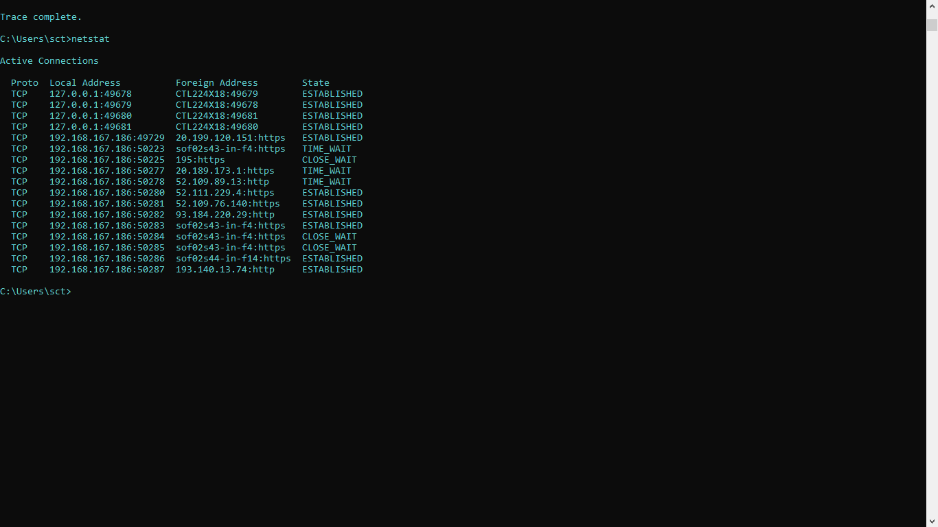

**Nslookup**

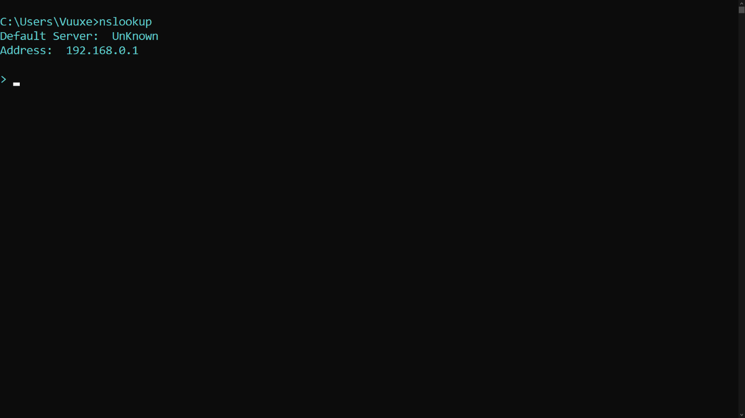  
Q1-) Some of the commands didn’t work.

Q2-) I tried some other version of these commands. Some of them worked but some didn’t.